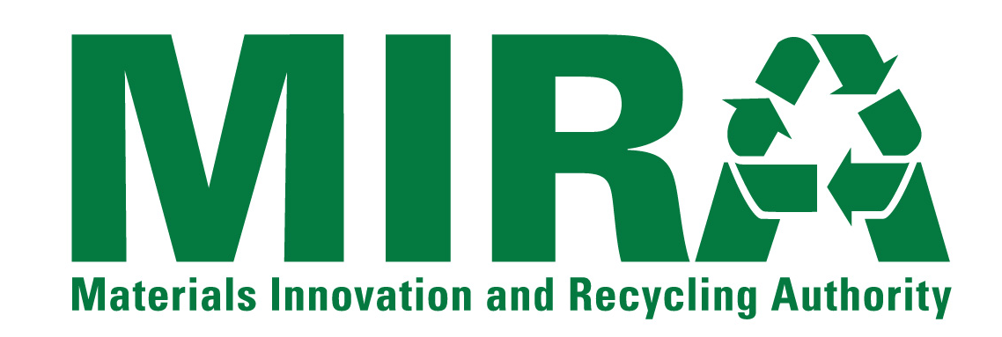
NOTICE OF INTEREST FORM
Individuals and firms that have an interest in the Materials Innovation and Recycling Authority (“MIRA”) solicitation listed below are encouraged to submit this Notice Of Interest Form to MIRA as early as they can. Forms should be submitted no later than the date specified below. Request For Bids/Proposals/ Qualifications documents and other information released by MIRA related to the solicitation will be directly provided to those firms that have submitted this Form to MIRA by the Form Due Date.
Solicitation: | RFP FOR AIR EMISSIONS TESTING AT THE CSWS POWER BLOCK FACILITY (RFP 15-EN-001)
RFQ Number:
Form Due Time/Date: | This form should be submitted to MIRA by 3PM on Monday September 22, 2014 in order to register for the Mandatory Pre-Proposal Meeting and Site Tour on September 23, 2014.
Provide the following information about the individual/firm and the contact person for the firm.
Name of Individual/Firm:
Name of Contact Person:
Title of Contact Person:
Mailing Address 1:
Mailing Address 2:
City, State, Zip Code
Telephone Number:
Fax Number:
E-Mail Address:
Submit this form to the MIRA contact listed below via e-mail, fax or correspondence as listed below.
MIRA Contact: | Roger Guzowski
E-Mail Address: | rguzowski@ctmira.org
Fax Number: | (860) 757-7742
Correspondence Address: | Materials Innovation and Recycling Authority  100 Constitution Plaza, 6th Floor  Hartford, CT 06103

